Sue Salthouse Leadership Fund  
administered by Hands Across Canberra

**Sue Salthouse Leadership Fund  
2025 Scholarship Grant Round**

This document was originally created by Easy Read. It has been updated to reflect the 2025 Scholarship Grant Round.

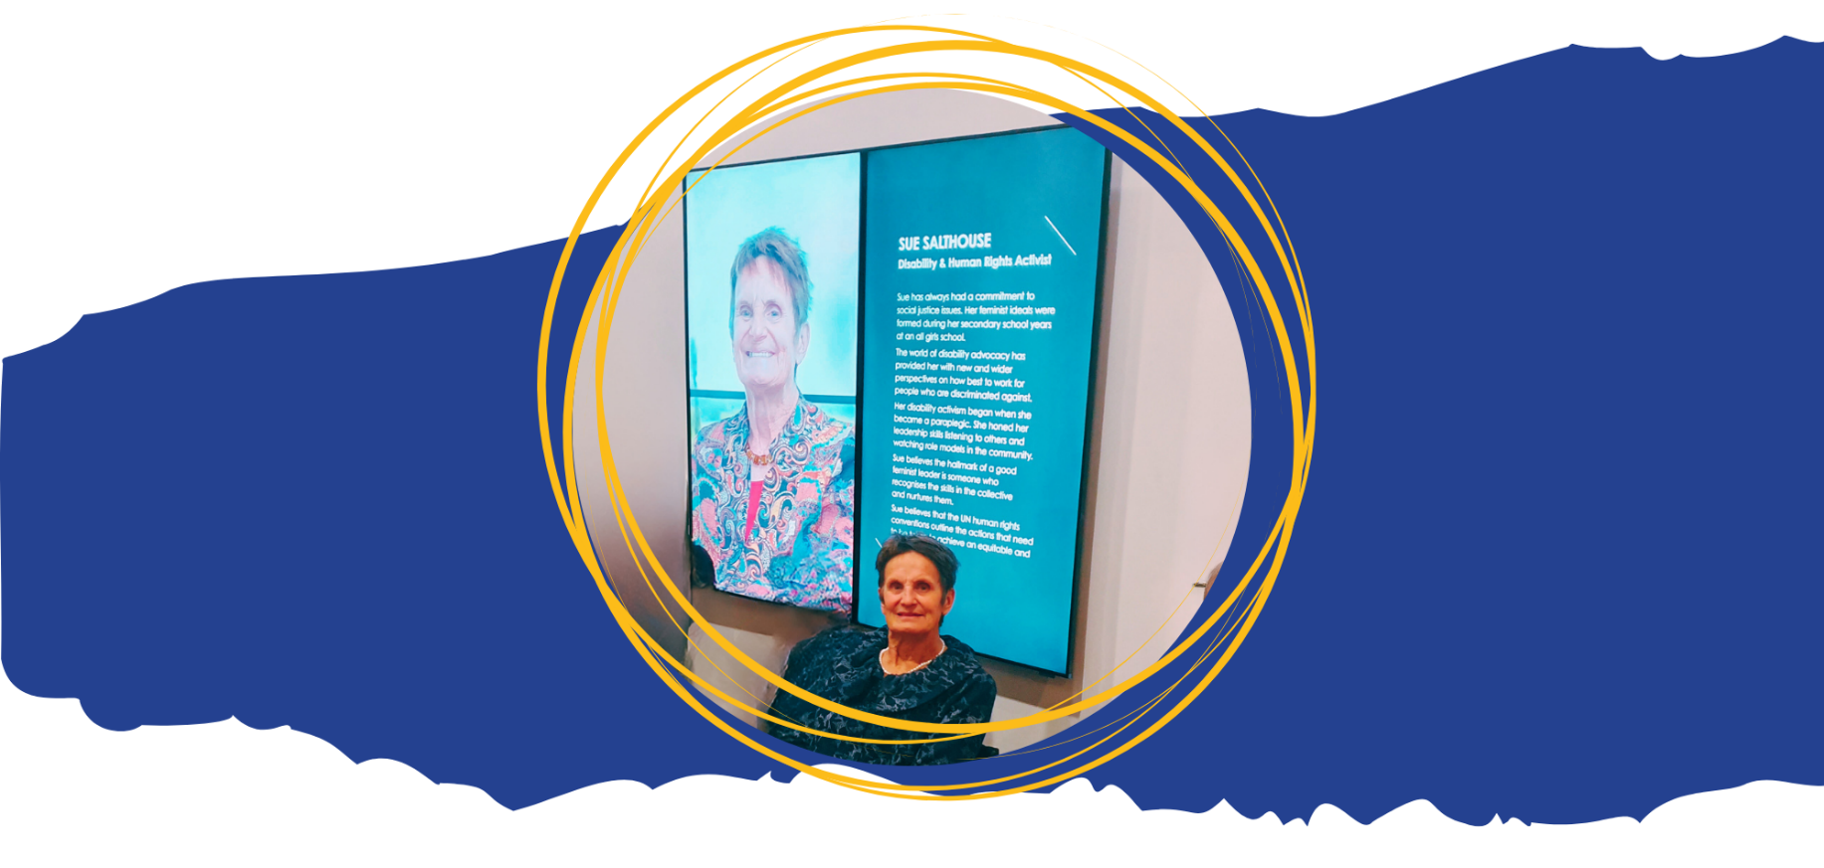

# About this document

|  |  |
| --- | --- |
|  | **Difficult Words** |
|  | This document is written in an easy to read way. |
|  | You might not know some words.  The first time we use those words they are **blue**.  We tell you what they mean. |
|  | We may use the words again later.  You can check the Word List at the back of this document. |
|  | You can ask for help to read this document.  You could ask:   * A family member * A friend * A support worker. |
|  | Hands Across Canberra |
|  | This document is written for Hands Across Canberra. |
|  | This document is an application form for the Sue Salthouse Leadership Fund 2025 **Scholarship Grant** Round.  This picture is of Sue Salthouse. |
|  | An application is when you are asking to do something.  This is often done using a form. |
|  | A scholarship is money used to support a person’s education. |
|  | A grant is money that is given to you for a certain use. |
|  | To apply you must:   * Live in ACT * Identify as living with a **disability.** |
|  | Disability is when someone may find it hard to:   * walk * see * hear * speak * learn. |
|  | Applications close Friday 5 September 2025.  1 month after 5 September your application will:   * Receive **feedback** * Receive an **outcome.** |
|  | Feedback means we will say how you could write an application better next time. |
|  | An outcome is the end result.  You will find out if you got the grant or not. |
|  | Application review |
|  | The Advisory Group will read each application and make sure that they meet the selected **criteria**. |
|  | The Advisory Group are people who are helping us to decide who gets a grant. |
|  | Criteria is a standard for judging or selecting something.  The criteria are:   * Your project must cost no more than you have said in your application |
|  | * Your project must meet its goals * It must help people in the community. |
|  | See the [grant **guidelines**](https://handsacrosscanberra.org.au/grants/sue-salthouse-leadership-fund-scholarship-grant-round-2025/)on our website for more information.  Guidelines are a set of rules you should follow. |
|  | | Other ways to apply |
|  | | You may also apply by:   * Email * Video * Phone. |

## If you need help with your application

|  |  |
| --- | --- |
|  | You can email these people for help:   * Julia from Hands Across Canberra [julia@handsacrosscanberra.org.au](mailto:julia@handsacrosscanberra.org.au) |
|  | * Advocacy for Inclusion [info@advocacyforinclusion.org](mailto:info@advocacyforinclusion.org) |

# If you are successful

|  |  |
| --- | --- |
|  | If you are successful you will be given the grant. |
|  | At the end of the project you will need to do an acquittal.  An acquittal is a type of report. |
|  | You will tell us:   * How you spent the grant money * How you met the project goals. |
|  | We encourage you to take photos to record your work.  Your photos can be part of your acquittal. |

|  |  |
| --- | --- |
|  | Application Form Use the back of the page if you need more space. Your details |
|  | **Your name:**  Write your first name and family name. |
|  | **Tell us your postcode:**  This is the 4 numbers at the end of your address. Each suburb and town has a postcode. |
|  | **Give us your email address:** |
|  | **Give us your best phone number:** |
|  | **I have a disability:**  Please mark 1 box.  🞐 Yes  🞐 No |
|  |  |
|  | **Please share your pronouns:**  Tell us the words to use when we talk about you.  🞐 Do not want to share  🞐 She / Her  🞐 He / Him  🞐 They / Them  🞐 Other please write: |
|  | **Are you Aboriginal or Torres Strait Islander:**  🞐 I am not either  🞐 Do not want to share  🞐 Yes I am Aboriginal  🞐 Yes I am Torres Strait Islander  **If yes please share your language group:** |
| Simple Earth graphic | **Are you a person from a** diverse cultural **background:**  Diverse culture means different to most people in Australia. This can include:   * The language you speak * Where you were born * Your beliefs and what is important to you.   🞐 Do not want to share  🞐 Yes  🞐 No. |
|  | Details of the project |
|  | **Tell us why you need funding:**   * Why you want to do the project * How your project gives leadership to the disability community. |
|  | **Tell us how you will do the project:**  What actions will you take. |
|  | **Other people who will help with the project:** |
|  | **Cost of the project for 1 year:**  Tell us the total cost. |
|  | **Tell us the** benefit **it will have for the disabled community:**  Benefit is a good change that happens. |
|  | **Tell us how you would like to** report back **to us.**  Reporting is when you tell us how the project has worked. |
|  | Any other information |
|  | Is there anything else you want us to know: |

# Word List

|  |  |
| --- | --- |
|  | **Advisory group**  A group of people who are helping us decide who gets a grant. |
|  | **Application**  An application is when you are asking to do something. |
|  | Acquittal.  An acquittal is a type of report. |
|  | **Criteria**  A standard for judging or selecting something. |
|  | **Disability**  When someone finds it hard to:   * walk * see * hear * speak * learn. |
| Simple Earth graphic | **Diverse culture**  When you are different to most people in Australia. This can include:   * The language you speak * Where you were born * Your beliefs and what is important to you |
|  | **Feedback:**  Feedback means we will say how you could write an application better next time. |
|  | **Grant:**  A grant is money that is given to you for a certain use. |
|  | **Guidelines:**  Guidelines are a set of rules you should follow. |
|  | **Outcome:**  An outcome is the end result. |
|  | **Scholarship**  A scholarship is money used to support a person’s education. |

Easy Read images by [The Easy Read Toolbox](https://www.easyreadtoolbox.info/) or through Creative Commons.

Easy Read document written by Teigan Southwell, The Easy Read Toolbox for Hands Across Canberra.